Officer Director Board Meeting
Friday, April 19, 2024

Opening:
The board meeting of the Dallas CPCU Society Chapter was called to order at 11:00 AM by Chapter President, Fredricka Myles via Zoom
Attendance:
Fredricka Myles, Martinique Castal, Tony La Rocca, Jonelle Young, Tia Tolbert, Peter Morford, Tara Letterman, Clint Bump, and Chris Lankford, Alex Salinas

Agenda:
- March meeting minutes were accepted by the Board.
- Financials-Tia
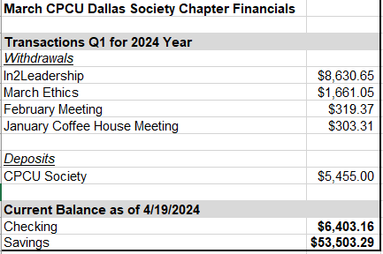
- Calendar of events
  - May: Career Fair/Professional Development and Golf Tournament-Precious is working on this event.
  - June: Women’s Veteran’s Recognition Day is June 12-Tony and Victoria will coordinate together.
  - July: Social/Family event-follow up with Precious; $2500 budget for social events.
  - August: I-Day -Precious
  - September: Student Engagement-Peter and Chris will meet, and plan to keep September as the month for the event.

Committee Updates:
- Community Good Works: Laura was not able to attend due to her losses.
- Communications/Web Master-Clint
  - Vengage was set up, but he does not have access.
  - Clint also needs access to add Bio information for Peter. Fredricka will help him get it set up.
  - Tony suggested Clint reach out to Gaudio, Jessica gaudio@theinstitutes.org to have someone removed from the email list.
- Registration and Arrangements- Tara
  - 11 registered on the Dallas website for the April event.
  - There were issues with people not receiving the meeting link if they registered early.
  - Peter will get trained from Precious on CE credits and will handle this moving forward.

- Programming/All Industry Day: Precious-no updates
- Education and Professional Development: Peter presented his Education Plan for 2024
- Social Media: Martinique-total followers as of April 2024
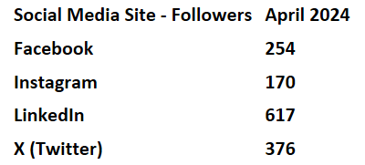
- DEI: Victoria/Tony-requested previous volunteer list from Jonelle.
- Student Outreach- Chris is meeting with Olivia on Thursday April 25th to learn about her past involvement and develop a strategy for this year.

Action Items:
- Tia made motion for $100 gift card for Laura for the loss of her father and brother. The board was all in favor. https://www.groupgreeting.com/
- Fredricka will follow up with the Institutes to see why meeting links were not sent for the April event, and to get a better understanding of how it works.
- Committee Plans are due by the May 17th Board Meeting.
- More discussion about offering in person sessions in addition to virtual. Have a hybrid option.

Adjournment: Meeting adjourned at 11:56 AM

